Lecture 1 was deleted accidently

Lecture 2 :-

Ques=> How Docker Works ?

=> lets konw a general workflow of docker :-

So in a docker ,

- A developer will define all its dependencies and requirement in a file name as “Dockerfile”.

dockerfile - describes steps to create Docker image . It’s like recipe with all ingredient and steps necessary in making dish .

- Now this docker file can be used to create docker images , so in the docker image you will have all the application , its requirement and dependencies .

- When you run the Docker images you will get a docker containers . so Docker containers are the run time instances of the docker image .

- And these image can also be stored on the online cloud repository called as Docker Hub . if you go to docker hub you will get lot of public images and you can store you own docker images as well .

- Now these images can be Pull to any environment which can create docker container in test environment or any other environment .

And we are SURE that our application will run same way using docker containers .

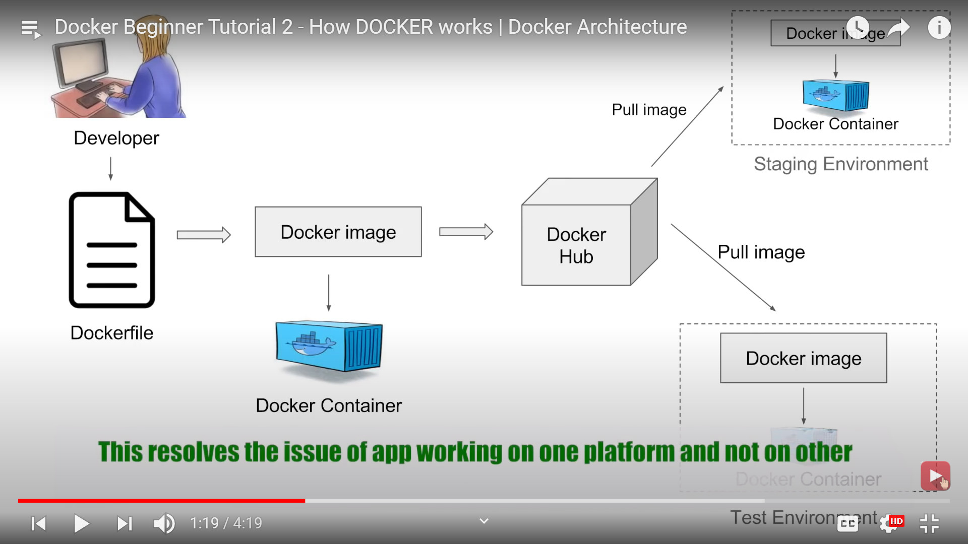

VIRTUALIZATION VS CONTAINERIZATION:-

Virtualization :- in concept of virtualization we have a software called as hypervisor , which is used to create and run multiple virtual machine (VM) on a host operating system . Now these virtual machine have their own operating system . so this will create a overhead on the host platform .

Also in the case of virtual machine we have to allocate a fixed memory and space to every machine, so lot of waste of memory and space .

Containerization:- Here we have a container engine and we do not have separate operating system but we have containers where we have the application and all its dependencies and it will use the Host operating system .
Now here the resources like space , memory are not fixed , it will be taken as per the needs of application so there is no overhead this is very lightweight and fast .

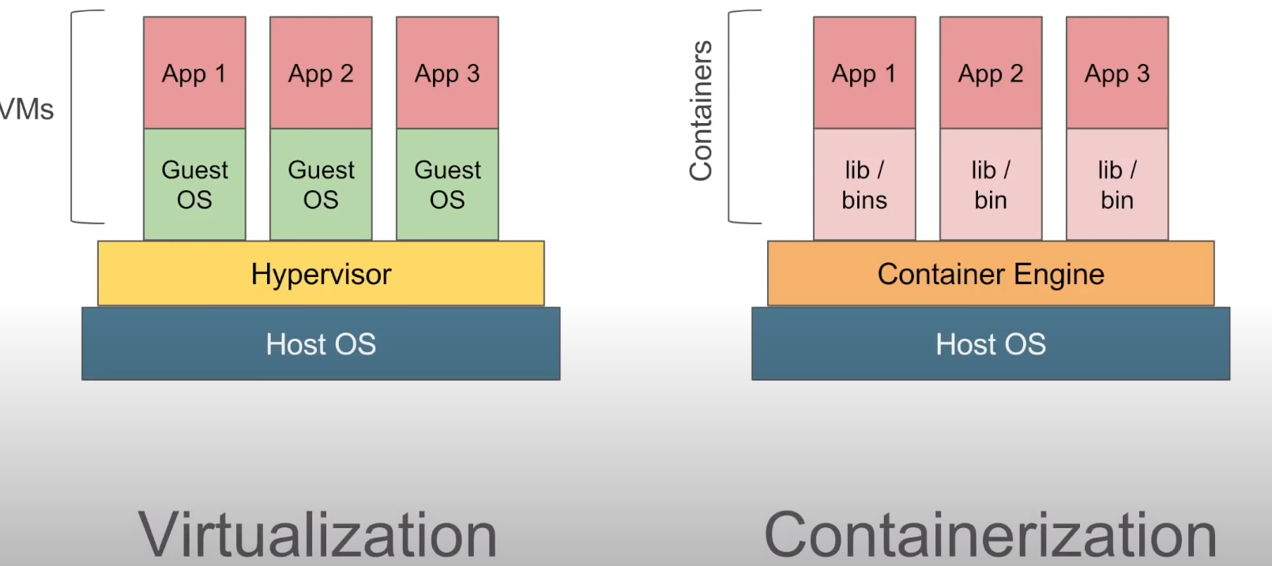

Now there can be scenarios where we need a virtual machine over a host operating system and then have containers .
For example :- if we want to run a windows application on the linux operating system for this we need a virtual machine first which will have our windows operating system then we can have containers over it .
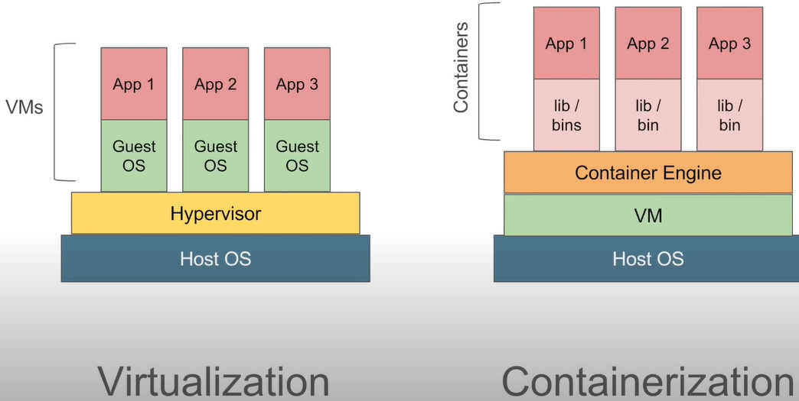

Now here in case of docker , the Container Engine is a Docker Engine .

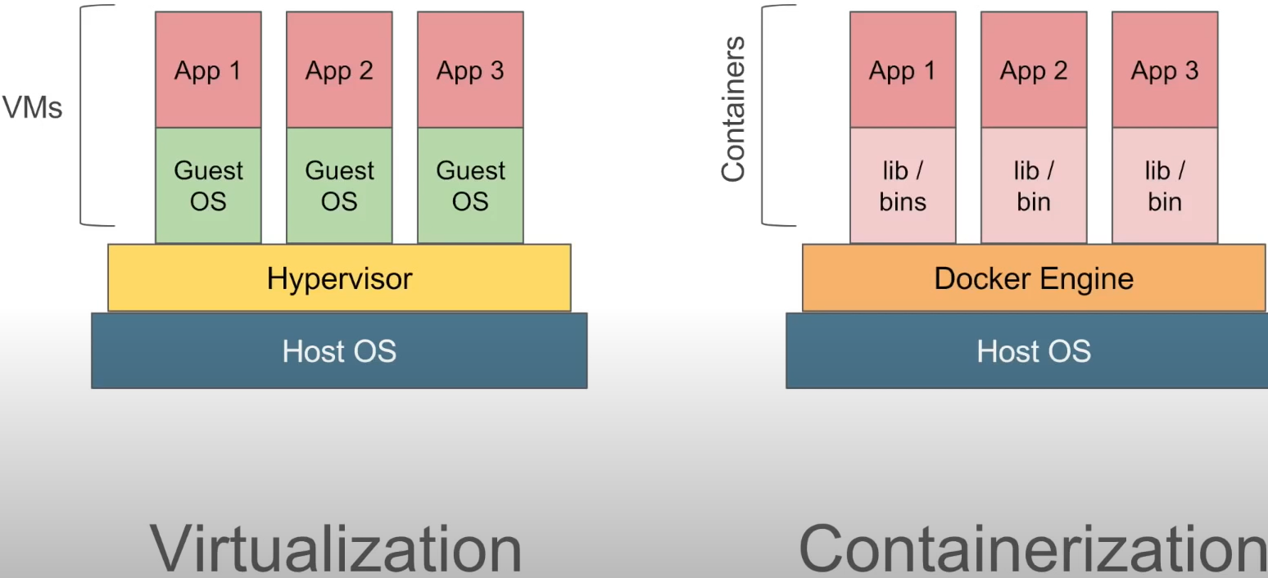

Docker has Client - Server Architecture lets uderstand this :-

In Docker, command line interface (CLI) is the client.

We have docker server or docker daemon which will have all the containers .
And the docker server receives the command from the docker client in the form of CLI command and the REST API request.
And all the components of docker client and server together forms the docker engine , so the docker daemon or server receives the commands from the docker client thought REST API or command line interface and the docker client and the docker daemon can be present on the same platform (same host / machine) or can be on different machine (different host).

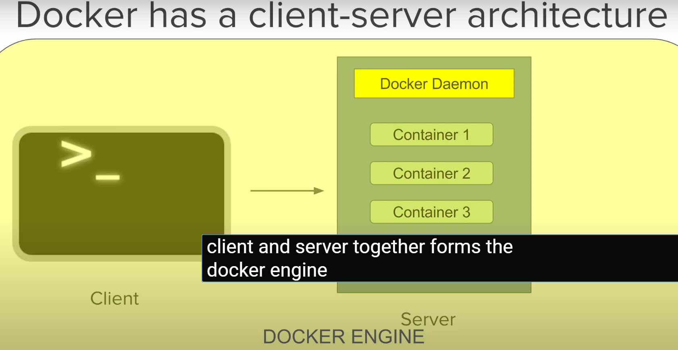

Now lets talk about Why Docker and Benfits of using Docker ??

We have already seen that docker solves the problem of a code running on different machine.
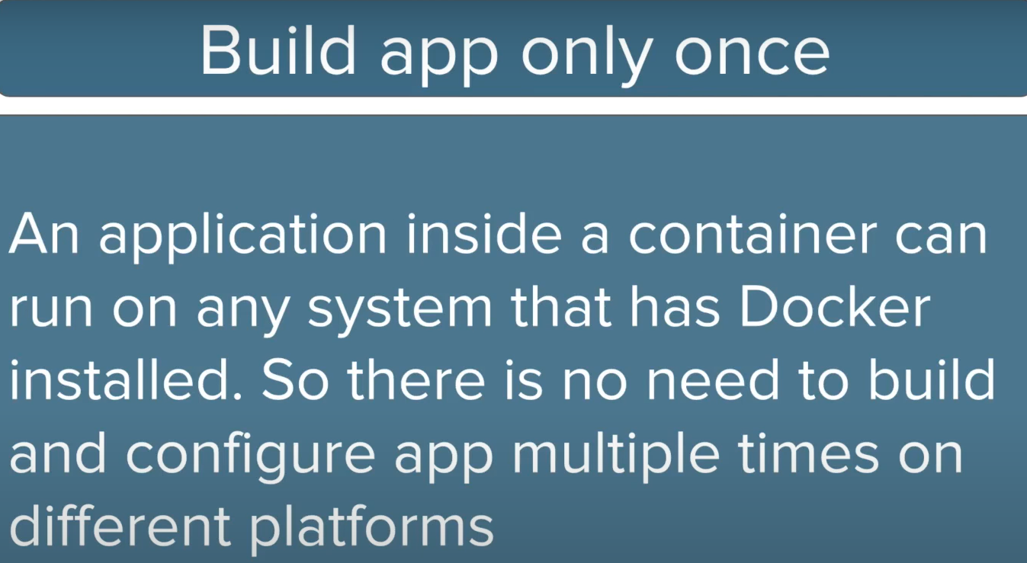

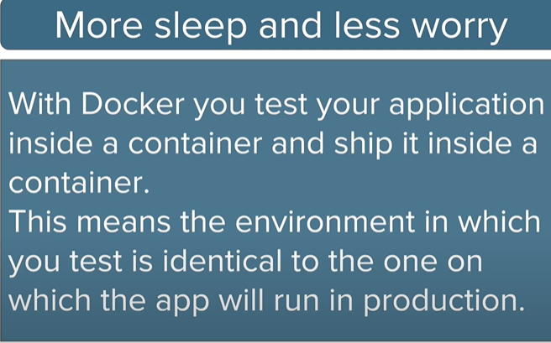

Also , portability is a great feature with the Docker , suppose you created your container uses an Amazon EC2 machine ,Now you can very easily port this container to a virtual box and it will run as it is .

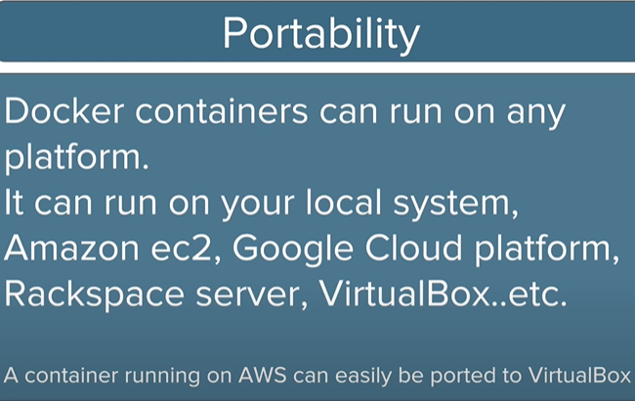

Also in Docker you can do version controlling , so if you changes in the images so you can commit them and version control them .

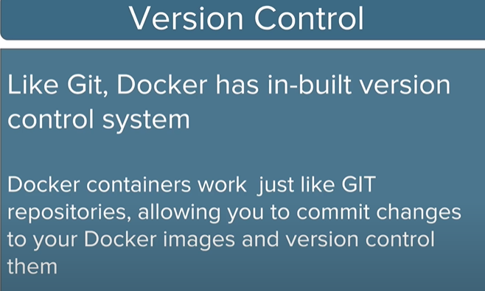

A great feature of Docker is every application works inside its own container and does’t interfere with any other application , working inside other containers or on the host operating system .

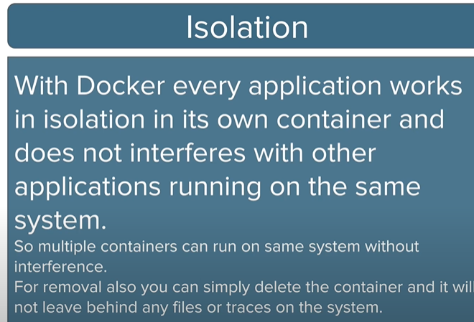

PLAY WITH DOCKER :-

https://labs.play-with-docker.com/

Its a docker playground , you can add a new instance and try out all the docker commands

HOW TO INSTALL DOCKER ON LINUX ?

https://docs.docker.com/manuals/

This is product manual link . In that link we will get information about how to install docker on various other linux os .

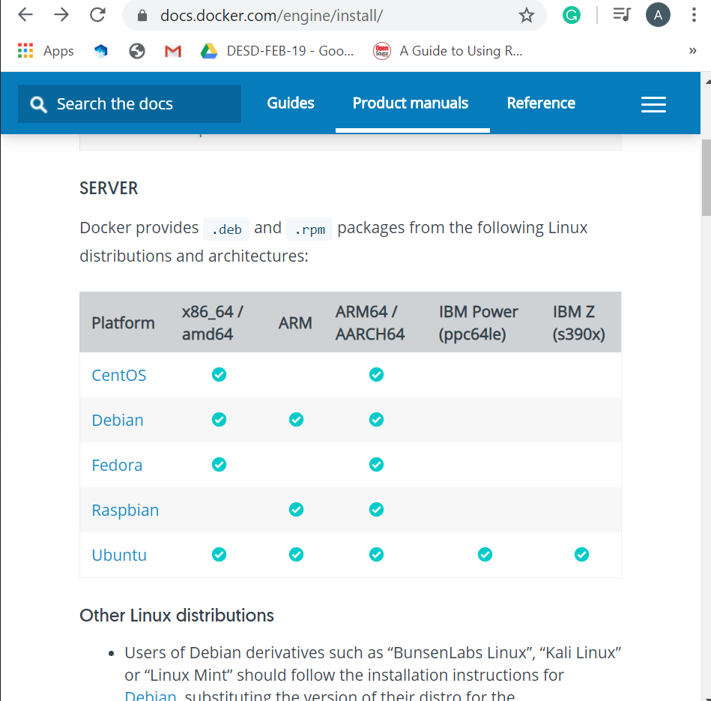
Now we will install docker on ubuntu

There are multiple of ways to install docker on ubuntu like with repository , with pakage or the easiest way is with script .

In this we will go through script installation mechanism.

Step 1 :- firstly check we have is there is older version
$ docker --version

Step 2 :- To unistall old version of docker which is pre install
$ sudo apt-get remove docker docker-engine docker.io containerd runc

There are basically two types of Script :-
- Stable one => get.docker.com
- Testing version of docker => test.docker.com

Step 3 :- just go to get.docker.com in your browser this will give you script .
But you don’t need to copy and paste that script ; just write two command on the terminal
Which is
- $ curl -fsSL https://get.docker.com -o get-docker.sh => by this we will download script file
- $ sudo sh get-docker.sh => by this we will run that script

hub.docker.com is the repository of the docker

$ docker --version => to check the docker version .

$ docker ps -a => to check docker image present .

And by run this docker image we can initiate container for that image .

NOTE:-

If you would like to use Docker as a non-root user, you should now consider
adding your user to the "docker" group with something like:

$ sudo usermod -aG docker your-user

Now run our first image from docker repository I.e hello-world

$ docker run hello-world

While running this image initiate into a container and when image will be save in local directory so that when we want to run that again we don’t need to download that again .

Actually what is happening is with docker deamon we will create even create multiple container with the docker image

$ docker info => you will get all the information about docker running on the system .

$ docker images => this will list out all the images

$ docker ps => this will list out all running containers

